ROLLER SETS

ADVANTAGE of using rollers over pincurls.
1. Less time to dry head.
2. Quick to set.
3. Comb-outs are smoother.
4. More volume or height can be achieved by using rollers.

TERMS:

Base: the area of the scalp that is occupied by a roller.

Base size: Is determined by the size of the roller being used.

Pivot point: the area from which the hair is directed to form a circular movement.

Brick layer: rollers placed in hair one roller to cover the break of the rollers below.

Roller size is determined by:
1) Length of the hair
2) The amount of curl that is desired in the finished look.

ANGLES USED IN A ROLLER SET
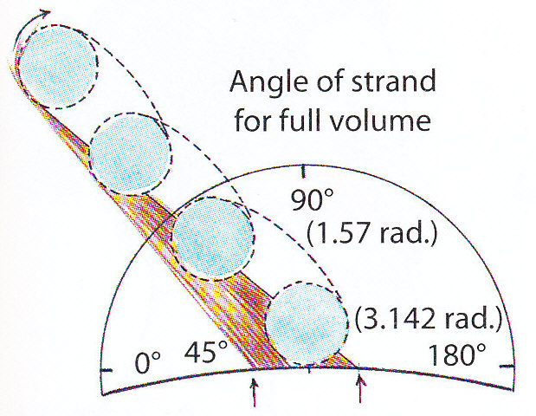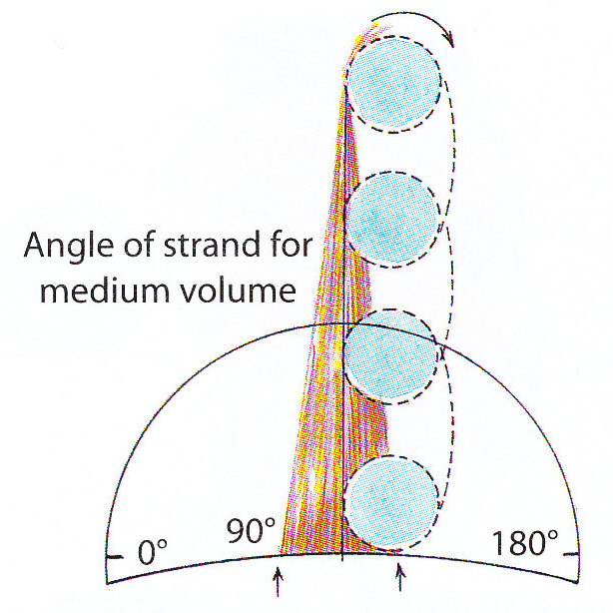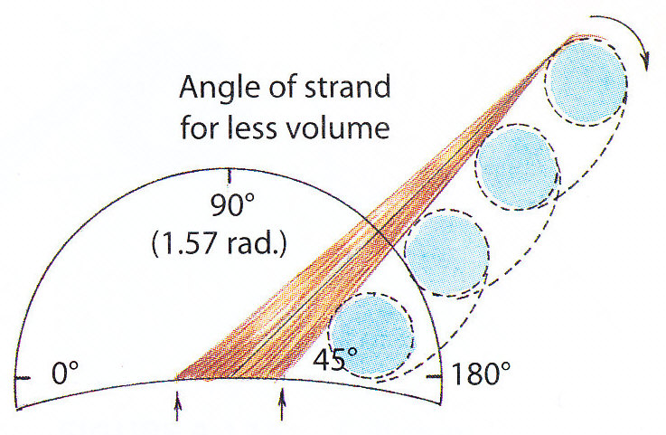

ROLLER PLACEMENT
Before beginning a roller set we must ask our client how she would like the finished product of her hairstyle to look. Once we know the look that the client wants then we can (in our mind) build a mental image of how we will set the hair to achieve this look.

The client will either request a hairstyle that has:
1. volume
2. no volume (referred to as "INDENTATION")

People who have some height to their hair are said to have "VOLUME" in their hair style. Volume is achieved by lifting the hair from its base and curling the ends under.
People who wear their hair relatively straight have no volume to their style. The term that is used to set the hair with no volume is "INDENTATION". Indentation or no volume is achieved by combing the hair flat to its base and curling the ends up over top of the roller.

TO CREATE VOLUME IN A HAIR STYLE
Depending on the desired amount of volume in the hairstyle the rollers can be placed:
1. On base
2. 1/2 off base
3. Off base

1. On Base:
- Setting the hair on base is used to produce maximum volume in a hairstyle.

Method:
Base size: 1 base size (length and diameter of a roller)

Body Position: directly behind the area you are working on.

Comb Hair: up at a 45^{ο} angle from the top part.
- curl ends under
Note: the roller should sit between the top and bottom parting (on base)
- clip the roller to the base of the hair.

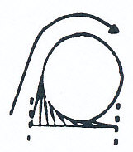

2. 1/2 off Base:
- setting the hair 1/2 off base produces a medium amount of volume in the hairstyle.

Method:
Base size: 1 base size (length and diameter of a roller)

Body Position: directly behind the area you are working on.

Comb Hair: up at a 90^{ο} angle from the centre of the base.
- curl hair around and under roller.
Note: the roller should sit 1/2 off of the base.
- clip at the centre of the roller.

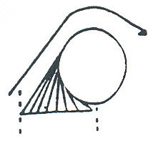

3. One off Base:
- Produces a minimum amount of volume in the hairstyle.

Method:
Base size: 1 base size (length and diameter of a roller)

Body Position: directly behind the area you are working on.

Comb Hair: at a 45^{ο} angle from the lower parting.
- curl hair around and under roller.
Note: the roller should sit below the lower parting (off base)
- clip at the centre of the roller.
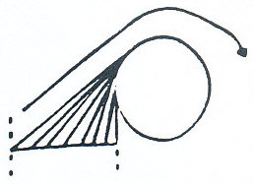
STYLING AREAS ON THE HEAD

To do a basic set we divide the hair into 4 styling areas.

STYLING AREA 1
1. Part the hair on the left side (straight back above the pupil of the eye).
2. Measure 1 roller length back along the part from the front hairline. Measure 1 roller length down the right side.

STYLING AREA 2
1. On the left side of the head measure 1 roller length down the left side.

STYLING AREA 3
1. Locate lower crown.

STYLING AREA 4
1. The remaining hair is used for styling area 4.

STYLING AREAS

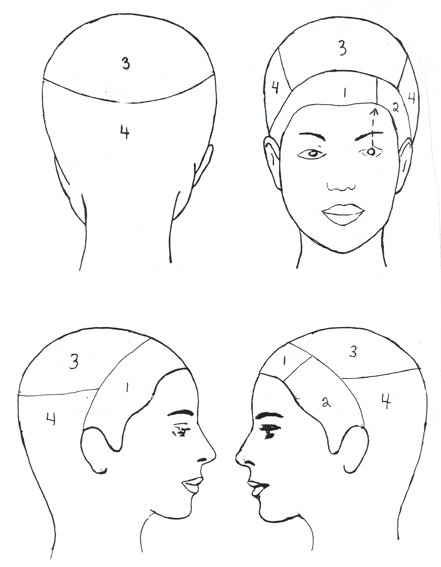
HOW TO SET A BASIC SALON SET

SETTING STYLING AREA #1
1. Locate pivot point at center front hairline. Along the back of the part in styling area #1 part to the pivot point. Place roller 1/2 off base to achieve medium volume. Pin at center roller.

To place 2nd and 3rd roller in styling area #1:
1. Along the back parting of styling area #1 (below the previous roller) measure 1 roller diameter, part to the pivot point. Place the roller 1/2 off base. Pin at center roller.
2. To place the 3rd roller in repeat procedure for 2nd roller.

To complete styling area #1:
1. Continue to bottom of section #1 measuring 1 roller diameter. Place rollers 1/2 off base.

SETTING STYLING AREA #2
1. Along the back part of styling area #2 measure 1 roller diameter.
2. Place roller 1/2 off base to achieve medium volume. Pin at center roller.

To complete styling area #2:
1. Continue to bottom of section #2 measuring 1 roller diameter. Place rollers 1/2 off base.

SETTING STYLING AREA #3
1. Brick layer styling area #3. Rollers are 1 roller diameter and are placed on base to achieve maximum volume.

SETTING STYLING AREA #4
1. Brick layer styling area #4. Rollers are placed 1/2 off base to achieve medium volume.

ROLLER PLACEMENT

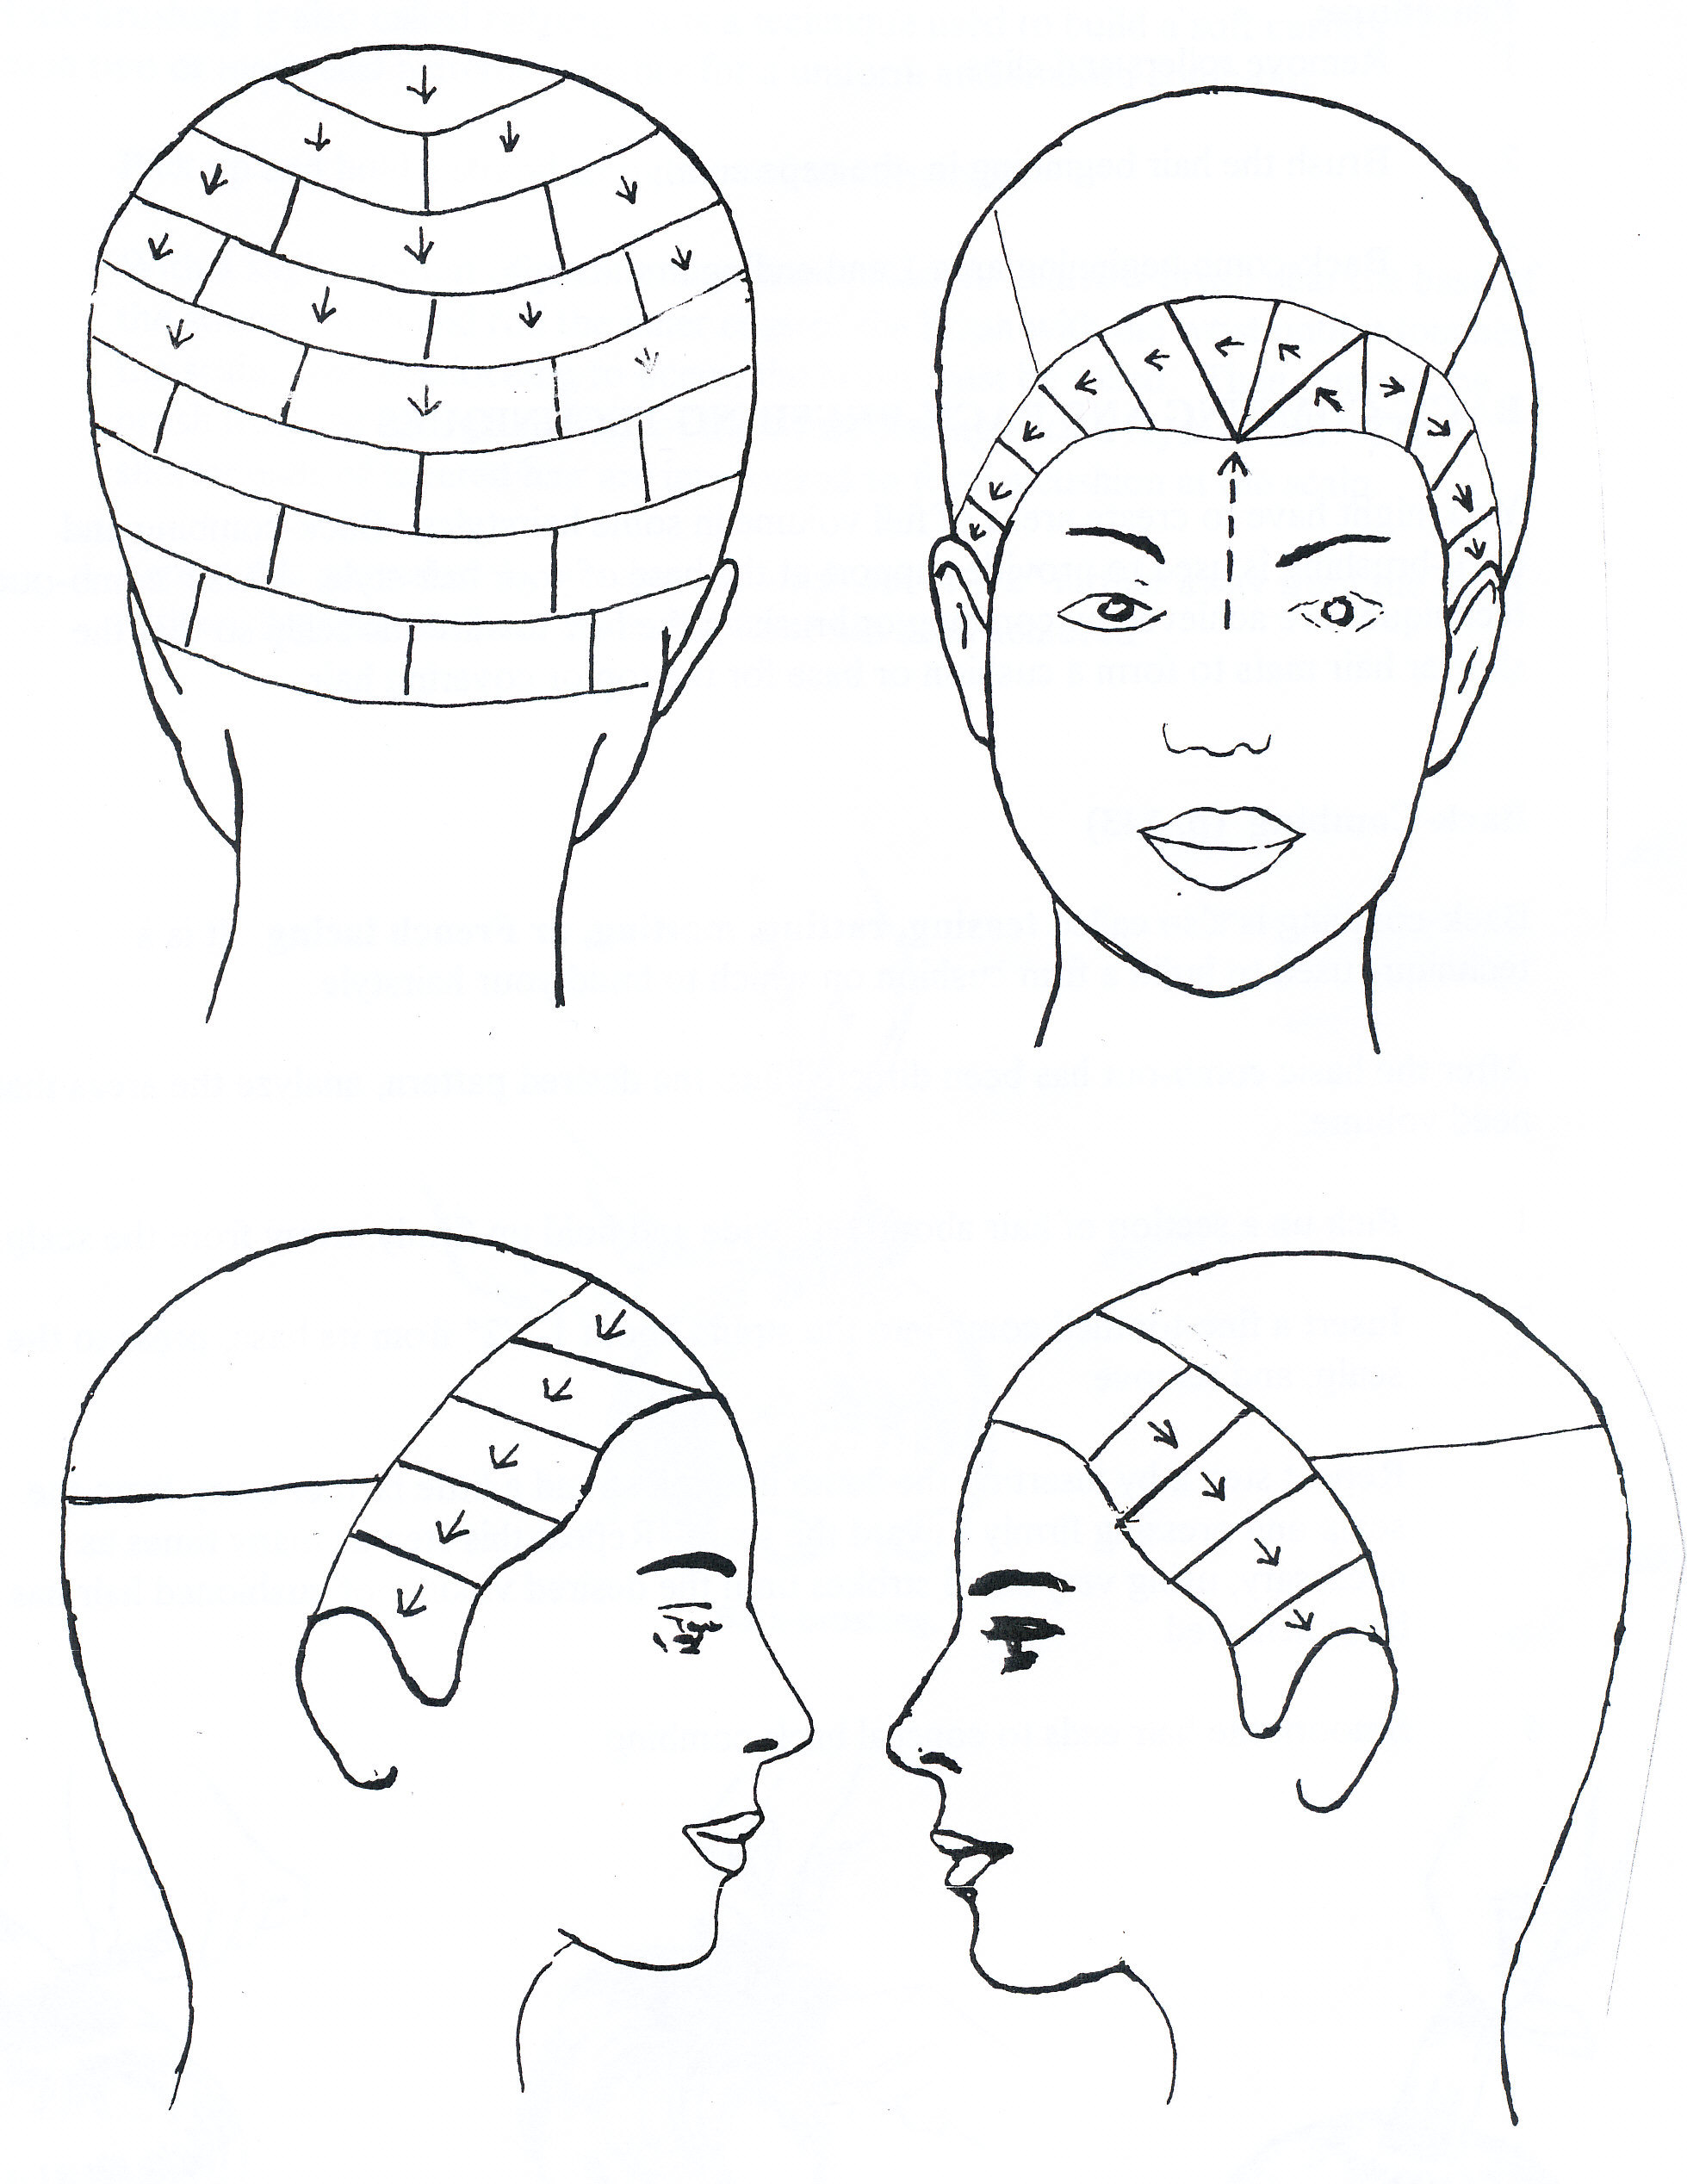
COMB-OUT TECHNIQUES

Procedure:
1. Remove rollers and clips.

2. Brush the hair beginning in the nape area.

3. Back-comb beginning area 1 and ending in the nape.

BACK-COMBING AND BACK-BRUSHING TECHNIQUES

You might have to create areas of full volume in some hairstyles. Back-combing and back-brushing is used to provide support at the base of your hair style. These comb-out techniques are achieved by combing or brushing the hair toward the scalp so that the shorter hair mats to form a cushion or base for the top or covering hair.

Back-Combing

Back-combing is also called teasing, ratting, matting, or French lacing. It is a technique used to build a firm cushion on which to build your hairstyle.

After the basic comb-out has been directed into the desired pattern, analyze the areas that need volume.

1. Pick up a section of hair about 3/4" wide and hold up firmly, away from the scalp.

2. Insert a fine-toothed comb into the strand about 1 1/2" from its base, press to the scalp, and remove.

3. Repeat step 2 by inserting the comb into the strand a little farther away from the scalp and pressing firmly toward the scalp. Repeat this step as many times as necessary, using very small strokes until the desired volume of cushioned hair has been achieved.

4. Smooth the hair ends to conceal back-combing.

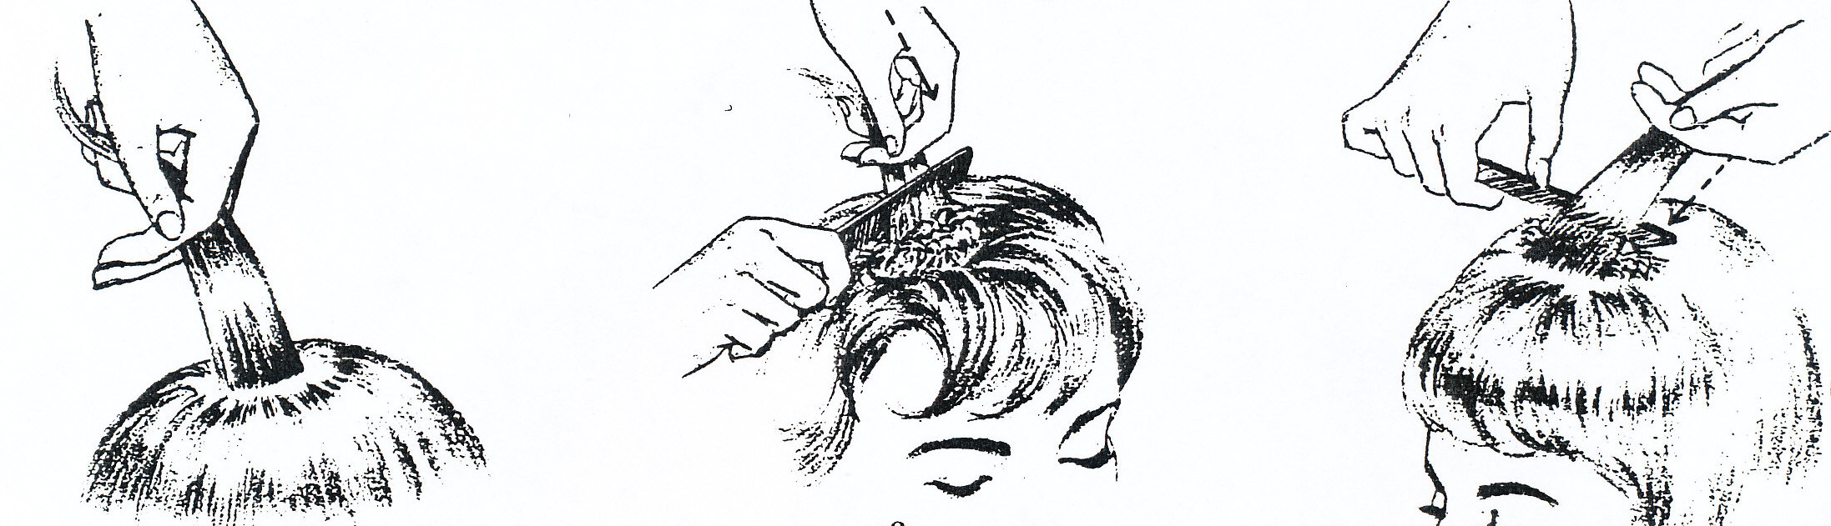
Back-Brushing

Back-brushing is also called ruffing. It is a technique used to build a soft cushion, or to mesh two or more curl patterns together for a uniform and smooth comb-out.

1. Pick up and hold a strand straight out from the scalp.

2. With a slight amount of slack in the strand, place a narrow brush near the base of the strand. Push and roll the inner edge of the brush with the wrist until it touches the scalp. For interlocking to occur, the brush must be rolled. Then remove the brush from the hair with a turn of the wrist, peeling back a layer of hair. The shorter ends of tapered hair are interlocked to form a cushion at the scalp.

3. Repeat this procedure by moving the brush about 1/2" farther away from the scalp with each stroke until the desired volume has been achieved.



